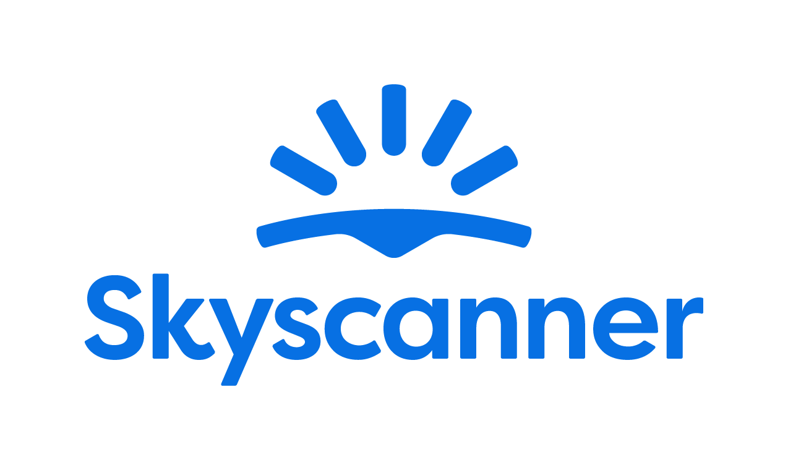

Localisation Style Guide

How to write and translate for Skyscanner in Polish

1. Our Tone of Voice 4
1.1 Playful 4
1.2 Geeky 5
1.3 Helpful 5
1.4 Using the tone of voice in localisation 7
2. General writing and translation guidelines 8
2.1 URL requirements 8
2.2 Placeholders, variables and tags 8
2.3 Inclusive language 9
3. Language-specific translation guidelines
10
3.1. Punctuation and spacing 10
3.1.1. Commas 10
3.1.2. Ellipsis 10
3.1.5. Hyphens and dashes 10
3.1.6. Full stops 10
3.2. Emphasis and intensifiers 10
3.3. References 11
3.4. Capitalisation 11
3.4.1. Glossary terms / product names 11
3.5. The use of Anglicisms 12
3.6. Abbreviations and acronyms 12
3.7. Addressing our users – Formality and T/V policy 12
3.8. CTAs and active voice 13
3.9. Linguistic sequence 13
3.9.1. Transliteration 13
3.9.2. Geo-terms 13
3.9.3. Airport names 13
4. Cultural sensitivity 14
4.1. Emojis and symbols 14
5. Translation guidelines per content type 14
5.1. User Interface (UI) 14
5.2. Marketing 14
5.3. SEO 15
5.4. Google Ads 15
5.5. App store 15
5.6. Editorial and blog posts 15
5.7. Emails and push notifications 16
5.8. Legal, Policies, Terms and Conditions 16
6. Other Skyscanner-specific guidelines 16
6.1. Use of Skyscanner brand 16
6.2. Feature naming 17
6.3. The use of “Best” 17
6.4. The use of “Discount” 18
6.5. Translating sustainability-related content 19
6.6. Accessibility guidelines 19
7. Useful resources and links 20

Our Tone of Voice

Skyscanner sounds like a Geeky Travel Pal. This means that:
- Our tone is playful
- Our energy is geeky
- Our message is helpful
Our brand promise is to be a helpful, honest travel ally. Our tone of voice should always support this:
- We give clear, useful information so travellers feel savvy.
- We are fair and transparent, so travellers feel confident and secure.
- We lead with empathy, so travellers feel valued and understood.
When localising, keep the same personality, but adapt expressions so they feel natural in your language and culture.

1.1 Playful
Our tone is playful. We write with a light, natural energy. Playfulness helps us feel human and builds trust – but it must never reduce clarity.
What playful means for us:
- A conversational tone, as if talking to a friend.
- A rhythm that feels lively, not flat or robotic.
- Turning travel frustrations into simple tips and “travel hacks”.
We’d say:
Do | Don’t
Teraz możesz porównywać loty bez spowalniania komputera dziesiątkami otwartych kart. | Ostrzeżenie: nasze narzędzie do porównywania lotów znajduje promocje tak szybko, jakby miało napęd rakietowy! Zapnij pasy podczas szukania oszczędności!

Always choose clarity over wordplay. If a device is hard to adapt or sounds unnatural in your language, do not use it.
Avoid
- “Fake-smart” corporate or management speak.
- Overly formal or stiff phrases.
- Trying too hard to be “LOL-funny”.

1.2 Geeky
Our energy is geeky: we love data, details and patterns – and we explain them in a human way.
What geeky means for us:
- We sound excited to share what we’ve learned.
- We show our travel expertise and curiosity.
- We break down complex information into simple steps.
Keep the tone enthusiastic but controlled. It should feel like a knowledgeable friend, not a lecture.
We’d say:
Do | Don’t
Znamy limity wagowe dla 137 linii lotniczych, dzięki czemu przejdziesz odprawę bez stresu. | Chcesz zgłębić temat różnic w ograniczeniach wagi?! Śledzimy KAŻDY. GRAM. w 137 liniach!!!

1.3 Helpful

Helpful is our foundation. If you must choose between playful, geeky and helpful, be helpful first.
Our writing should:
- Make complex travel information simple.
- Make confusing situations clear.
- Make overwhelming choices manageable.

We’d say:
Do | Don’t
Chcesz wiedzieć, w jaki dzień lot będzie najtańszy? Możesz na nas liczyć. | Jeśli przytłacza Cię liczba stron i kart, gdy szukasz najtańszego dnia na lot, możesz odetchnąć. Jesteśmy tu, aby Ci pomóc.
How to write helpfully
1. Put travellers first
- Focus on what they need to know, not on us.
- Start with the benefit or instruction, then explain how we know.
- Ask nicely - to help the traveller take action, they’ll be more inclined if we’re polite and respect their time.
Do | Don’t
Dowiesz się, które z tysięcy lotów są najtańsze | Przeszukujemy tysiące lotów, aby wskazać Ci najtańsze
Dostawca potwierdził Twoją rezerwację | Dostawca przetworzył Twoją płatność i Twoja rezerwacja jest potwierdzona

2. Be honest, upfront and take responsibility
When sharing bad news or apologising:
- Drop most of the playfulness.
- Always apologise if something is our fault. If it isn’t, show empathy instead.
- Be clear about what happened, what will happen next, and what we’re doing to fix it.
- Say sorry once, sincerely. Focus on solutions, not on how bad we feel.
- Avoid cold phrases like “We apologise for the inconvenience.
Do | Don’t
Niestety Twój lot został anulowany przez przewoźnika. Rozumiemy, że to frustrujące. Bez obaw – zadbamy, aby zwrócono Ci środki. | Twój lot został anulowany przez przewoźnika. Zobaczymy, czy uda Ci się otrzymać zwrot pieniędzy.
Niestety przewoźnik anulował Twoją rezerwację. | Przepraszamy, ale Twoja rezerwacja została anulowana przez przewoźnika.
Coś poszło nie tak i nie możemy wyświetlić dostępnych lotów. Wyszukaj ponownie lub spróbuj później. | Coś poszło nie tak i nie możemy wyświetlić dostępnych lotów. Przepraszamy za utrudnienia.

3. Keep it short and simple
- Use short sentences and simple structures.
- Remove unnecessary words and repetition.

Do | Don’t
Potrzebujesz pomocy? Skontaktuj się z naszym zespołem obsługi klienta | Jeśli potrzebujesz pomocy, pamiętaj, aby skontaktować się z naszym zespołem obsługi klienta

1.4 Using the tone of voice in localisation
When translating or adapting content for Skyscanner:
- Keep the three qualities – playful, geeky, helpful – but express them in ways that fit your language and culture.
- Prioritise meaning and clarity over matching English phrasing.
- Replace wordplay (rhyme, alliteration, puns) with devices that work naturally in your language – or skip them if needed.
- Keep the friendly, human, travel-loving personality in every sentence.
Your goal: in every market, travellers should read the text and think,
“This sounds like a smart, friendly travel pal who’s genuinely here to help.”

General writing and translation guidelines

URL requirements
When translating or creating URLs for Skyscanner, follow these technical rules to keep URLs consistent, readable and safe across all markets. These are very important, since not following the guidelines may result in whole pages breaking and being unavailable for the audience.

- No spaces - If you need to separate words, use a standard hyphen -.
Do | Don’t
wypoczynekwmiescie | wypoczynek w miescie
wypoczynek-w-miescie

- All lowercase

Do | Don’t
wypoczynekwmiescie  wypoczynek-w-miescie | Wypoczynek w miescie  Wypoczynek-w-miescie

- No extended or special characters. Replace them with the basic Latin letter.
Do | Don’t
a, c, e, l, n, o, s, z | ą, ć, ę, ł, ń, ó, ś, ź, ż

Placeholders, variables and tags
Placeholders, variables and tags are there to make the text dynamic (e.g. inserting a city, date or price) or to format it. They must not be translated, deleted or changed.

Always keep them exactly as in the source, adjusting the word order so it makes sense, and make sure the sentence is still natural and grammatically correct in Polish. Make sure to insert spaces where needed before/after the tags to avoid words being glued together when the placeholders are populated.

In case the placeholder is not supported by the translation tool and shows as editable text instead of a tag, make sure not to translate the content but keep it as in English.

When you approach placeholders, make assumption that they will be used in Nominative:

✖ Lotniska w Warszawa

We can hack the system a bit ;] by using a colon:

✔ Lotniska w: Warszawa

Be careful with placeholders for numbers:

✖ [number] tygodni

as it can easily go wrong: 4 tygodni. In such cases use abbreviation

✔ [number] tyg.

Inclusive language
Our language should be inclusive, welcoming and respectful to all travellers. When translating for Skyscanner, avoid stereotypes, unnecessary references to gender, family, age, ability, or background, and choose wording that includes as many people as possible. Always prefer neutral, precise terms over clichés or labels.
- Use gender-neutral language where possible.
- Do not assume who people travel with, how they look, or what they can do.
- Avoid jokes or idioms that rely on stereotypes about nationality, age, gender, religion, or any other group.
- Focus on travellers’ needs and situations, not on labels.

Do | Don’t
Świetne dla grup, par lub osób podróżujących w pojedynkę | Świetne dla matek z dziećmi
Idealne dla osób, które cenią sobie ciszę podczas pobytu | Idealne dla osób starszych, które nie lubią hałasu
Niektóre ulice są strome, co może być utrudnieniem dla osób z ograniczoną mobilnością. | Ten obszar jest nieodpowiedni dla niepełnosprawnych.
Lokalne restauracje mają propozycje dostosowane do różnych potrzeb i preferencji żywieniowych. | Lokalne restauracje mają dania dla osób odżywiających się normalnie i na specjalnych dietach

Language-specific translation guidelines

Punctuation and spacing
Please make sure you are familiar with Polish punctuation rules, as they are made for clearer and better comprehension of the text. (When in doubt go to Słownik Języka Polskiego site – you will find answers to most questions plus some useful Q&A).

Commas
We use the traditional comma.

Ellipsis
Use horizontal ellipsis (‘wielokropek’ – Unicode U+2026) available on Windows through Alt+0133, Alt+; on MacOS and Alt+K on Linux.
    - Exclamation marks
Avoid using exclamation marks, as English likes them too much while Polish is more reserved. Try to keep your translation informative and neutral, don’t shout at users.
    - Quotation marks
Use Polish quotation marks (‘low’ and ‘high’): „text” (alt+0132 and alt+0148).

Hyphens and dashes
General rule is to use n-dashes (alt+0150). Hyphens can be used in certain conditions (eg. COVID-19). Do not use m-dash (—) at all.
✖ Od starożytnych piramid po aktywne wulkany — odkrywaj najpopularniejsze miejsca.
✔ Od starożytnych piramid po aktywne wulkany – odkrywaj najpopularniejsze miejsca.

Full stops
We use the traditional full stop BUT do not use full stop in headings. Read client description in Memsource (when available) carefully.
✖ Tanie loty do miast świata.
✔ Tanie loty do miast świata

Emphasis and intensifiers
Sometimes we use formatting and wording to emphasise key information for it to be easy to spot, or as an intensifier for a part of the message.
As a rule of thumb, prefer simple formatting (bold or italics) for emphasis and avoid using ALL CAPS or too many exclamation marks, as they can feel like shouting or spammy marketing.
Do | Don’t
Zarezerwuj dokładnie taki samochód, jaki chcesz 🚘 | Zarezerwuj DOKŁADNIE taki samochód, jaki chcesz 🚘
 | Zarezerwuj dokładnie taki samochód, jaki chcesz!!!!!!! 🚘🚘

References
When you refer to other content (pages, features, sections, links), use clear, consistent names and, where relevant, the exact label used in the UI. The UI reference should be surrounded by Polish quotation marks.
Do | Don’t
Kliknij przycisk „Powrót do wyników” poniżej, aby wrócić do wyszukiwania na Skyscannerze i spróbować ponownie. | Kliknij przycisk POWRÓT DO WYNIKÓW poniżej, aby wrócić do wyszukiwania na Skyscannerze i spróbować ponownie.

Capitalisation
Do not overuse capital letters. English likes them, Polish not so much. Especially in names of legal documents. If the name of the document is not fixed (eg. by EU), it’s safer to put it in lower cases:
✖ Centrum Pomocy
✔ Centrum pomocy
✖ Polityka Okoliczności Wyjątkowych
✔ Polityka okoliczności wyjątkowych
Use capital letters, when you address the user directly: Tobie, Ciebie, etc.

Glossary terms / product names
Glossary terms and product feature names should follow a consistent capitalisation pattern across the product. Use sentence case for descriptive unless they are treated as branded names in your language.
Keep capitalisation the same in UI and running copy, and do not switch between different styles (for example, avoid mixing “Price Alerts” and “price alerts” without a clear rule).

The use of Anglicisms
Avoid unnecessary Anglicisms if there is a clear, natural equivalent in the target language. Only keep English words when they are widely used and expected by travellers (for example, brand names or common digital terms). Make sure any English term you keep fits the tone and formality of your market and stays consistent across the product.
Do | Don’t
Use the local equivalent of “deal”, “trip”, “offer” if it sounds natural and common. | Mix English and local words in the same phrase when it feels trendy but unclear, e.g. “flight deals super baratos” if this is not normal usage in your market.

Abbreviations and acronyms
Use abbreviations and acronyms only when they are widely understood by travellers in your market (for example: airport codes, well-known transport terms). If there is a risk of confusion, write the full term on first mention and add the abbreviation in brackets. Avoid creating new abbreviations just to save space.

Addressing our users – Formality and T/V policy

As we want to comply with Skyscanner’s ToV:
we DO NOT use Pan/Pani to address users as it would make the style too formal and stiff,
we DO use capitalized Tobie, Ciebie, Ty, Wy, Wam, Was, etc. instead, since it’s more direct approach
we DO use gender-neutral forms:
✖ Czego szukałeś(-aś)?
✔ Czego szukasz?
✖ Przenosimy Cię na stronę dostawcy usług, abyś mógł/mogła zrobić rezerwację
✔ Przenosimy Cię na stronę dostawcy usług, gdzie możesz zrobić rezerwację

CTAs and active voice
Use the active voice wherever possible, especially in headlines and CTAs. The active voice is usually clearer, and it sounds more like a direct conversation with our users.

- CTAs should be short, direct and written in the active voice.
- Focus on what the user can do next, using clear verbs and simple structures.
- Avoid long or vague phrases and avoid passive constructions where the user is not the clear subject.
- When adapting to each language, keep CTAs natural and action-oriented, in line with local expectations for apps and websites.
- Use imperative mode in buttons and calls to action.

Do | Don’t
W niniejszej Polityce wielokrotnie używamy pojęcia „dane osobowe” | W niniejszej Polityce wielokrotnie używane jest pojęcie „dane osobowe”

Linguistic sequence

Transliteration
Follow common local usage and official standards when transliterating place names, stations, and key travel terms. Be consistent within the language: don’t mix different transliteration systems in the same text. Do not invent new spellings or “localise” brand names that are normally kept in Latin script. If there is an established local exonym (well-known local version of a place name), use that; otherwise use the standard transliteration.
Do | Don’t
München | Monachium
stacja Paris Nord | stacja Paryż Nord

Geo-terms
Use the official or most widely used local names for countries, cities, regions and airports, and keep them consistent across all content. Avoid outdated, politically sensitive or rarely used forms, and don’t over-translate when travellers expect the original name (for example in airport names or well-known landmarks).

Airport names
When translating airport names, refer to the official sources to make sure the name is correct.
Never add the word “airport” when translating an airport name to avoid duplication; it’s usually used to populate placeholders in a running copy, and the term “airport” is added to the copy when needed.
Example:
Wylot z lotniska @@airport-name@@
Do | Don’t
Paryż-Roissy-Charles de Gaulle | port lotniczy Paryż-Roissy-Charles de Gaulle

Cultural sensitivity

Emojis and symbols
- Use emojis and symbols sparingly and only where they support clarity or add a light, on-brand touch.
- Make sure they are universally understood and appropriate in your market.
- Avoid replacing key words with emojis, and never use emojis in legal, policy or serious problem/incident messages.

When possible, replace any emojis or symbols present in the source copy if they are culturally inappropriate or the meaning is unclear in your market. When not possible/editable, flag the inappropriate content to Skyscanner and suggest a more suitable equivalent.

Translation guidelines per content type

User Interface (UI)

- Be short, clear and action-focused. Prioritise clarity over playfulness.
- One idea per string; avoid ambiguity and extra words.
- Use the same wording consistently across product

Marketing
There is more room for creativity for Marketing content – we want the copy to sound natural, fluid and inspirational. Avoid sticking too close to the source text and make sure the translation feels like it has been created in the target language originally.
- Use the playful, geeky, helpful Skyscanner voice, but keep promises realistic and compliant
- Focus on traveller benefits: saving time, money, effort, or discovering new places.

SEO
- Prioritise natural language, not keyword stuffing
- Write the way travellers actually search and think, while keeping our tone.
- Use clear, descriptive headings and titles
- Keep meta titles and descriptions concise and helpful

Google Ads
- Be very concise; use clear benefits and a direct call to action. There are usually strict character limits.
- Avoid clickbait and unprovable claims (no “#1”, “best”, “cheapest ever”).
- Avoid exclamation marks and other unnecessary punctuation.
- Use common search language that travellers would type.

Do | Don’t
Porównaj loty do Tokio, oszczędzając czas | Tutaj znajdziesz absolutnie najlepsze loty do Tokio!
Znajdź tanie loty do Rzymu | Gwarantujemy, że u nas znajdziesz najtańsze loty we wszystkich kierunkach!

App store
- Highlight main benefits and features clearly (search, compare, track prices).
- Use simple, natural phrases that work well in screenshots and previews.
- Avoid superlatives and guarantees.

Do | Don’t
Porównuj loty, hotele i oferty wynajmuj samochody w jednym miejscu. | Jedyna aplikacja do planowania podróży, jakiej potrzebujesz.
Ustaw alerty cenowe, aby otrzymywać powiadomienia o spadkach cen. | Za każdym razem znajdziesz najlepsze loty do dowolnego miejsca na świecie.

Editorial and blog posts
- Use a warmer, more descriptive tone, but keep it factual and practical.
- Balance inspiration with concrete tips (times to go, rough prices, how to get around).
- Adapt and localise content that isn’t relevant for your market
Do | Don’t
Jeśli zależy Ci na niskiej cenie, szukaj lotów w środku tygodnia i unikaj dni urzędowo wolnych od pracy. | Tylko głupcy latają w lecie – lataj wiosną albo wcale.

Emails and push notifications
- Keep subject lines short and clear, and body copy friendly, helpful and inspirational.
- Make it obvious what the traveller can do next (search, check a deal, manage a booking).
Do | Don’t
Cena Twojego lotu do Lizbony jest teraz niższa | Znaleźliśmy niewiarygodnie niską cenę!!!
Ceny lotu z Londynu do Lizbony są niższe. Sprawdź aktualne opłaty i dowiedz się, kiedy zarezerwować lot. | Kliknij teraz! Promocja może przepaść na zawsze. To najlepsze loty – taka okazja nigdy się nie powtórzy.

Legal, Policies, Terms and Conditions

- Prioritise accuracy, clarity and consistency over tone.
- Be precise and neutral; avoid jokes, idioms and emotional language.
- Do not add promises or interpretations that are not in the source text
Do | Don’t
Te warunki dotyczą wszystkich wyszukiwań i rezerwacji na naszej platformie. | Te warunki zwykle mają zastosowanie do większości wyszukiwań i rezerwacji.
Nie gwarantujemy dostępności ani ceny lotów do momentu potwierdzenia rezerwacji. | Nie zawsze możemy zagwarantować dostępność lub cenę przed potwierdzeniem rezerwacji.

Other Skyscanner-specific guidelines

Use of Skyscanner brand
The name Skyscanner is a core part of our brand identity and must be treated consistently across all languages. It should remain recognisable, correctly spelled, and used in a way that feels natural to the local audience while still protecting the brand. Please inflect the name Skyscanner – Skyscannera, Skyscannerze, etc.

Feature naming
When localising feature names, focus on meaning and user clarity, not on literal translation. A good feature name should be:
- Short and easy to scan
- Clear about what the feature does
- Natural and familiar in your language
- Consistent with terminology used by other travel providers in your market
Avoid direct, word-for-word translations if they sound strange, misleading, or carry unintended meanings. Only use the English name if it is already widely known and expected in your market.
Before finalising a name, check:
- How similar features are named by local travel providers
- Whether the term is already standard or commonly understood by travellers
- Whether the name could be misinterpreted
Example:
The English term “Packages” may be misunderstood as “parcels” in some languages, while we refer to a new vertical offering package holidays including flights and a hotel.
A clearer, more natural option in your language could be “pakiety wakacyjne” or the local equivalent travellers recognise.

The use of “Best”

Be careful with the use of “best” and superlatives in general. We are unable to claim that we can find travellers the “best prices” and “best deals” as this is an objective claim versus our competition that we would not be able to substantiate.

We can, however, use “Best” when there is a clear disclaimer explaining how "best" is measured.

Example:
Do | Don’t
To najlepsza cena, jaką znaleźliśmy na naszej platformie w oparciu o zgromadzone dane. | To najlepsza cena za lot.

Do | Don’t
Porównaj promocyjne ceny lotów do Paryża i znajdź opcję, która Ci odpowiada. | Znajdź najlepsze loty do Paryża.

For example, we can sort our flight results by “Best” results since we have a disclaimer clearly explaining how this is measured:

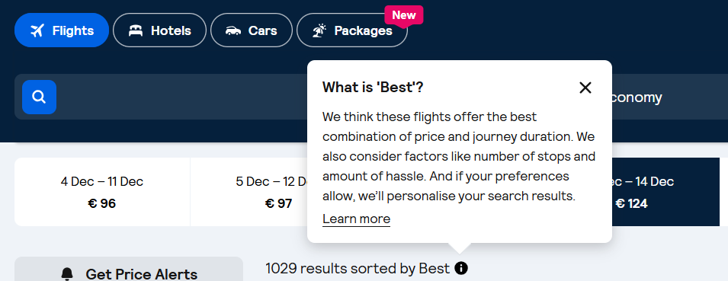

Generally, when the English copy says “best”, it’s safe to translate it the same way. When this is not the case, do not use “best” or other superlatives. Instead, use subjective claims such as “epic prices” or “amazing deals”.

The use of “Discount”

Skyscanner never offer discounts to users. Any discounts come from partners (for example Trip.com), not by Skyscanner.
For this and especially for legal reasons we can therefore never imply that “we offer” or “Skyscanner offers” a discount. This must be translated in a neutral way, i.e. “You are offered a discount”.

Never use the translation or equivalent of “discount” when the English source refers to a “deal” or “price drops” – these are not discounts but results of price fluctuation and it would be legally incorrect to refer to discounts.

Do | Don’t
Nasza funkcja Drops pokazuje, kiedy ceny spadną o co najmniej 20%. | Nasza funkcja Drops daje Ci co najmniej 20% zniżki.

Translating sustainability-related content
When localising content about anything related to sustainability for Skyscanner, it’s essential to communicate responsibly and avoid greenwashing. Travel has an undeniable environmental impact, and our language must reflect this honestly and transparently. Use the following principles when translating or adapting sustainability-related content:
- Prefer comparatives over absolutes. Use relative statements such as “X is more sustainable than Y”, rather than implying that any option is fully sustainable.
- Avoid superlatives. Do not use expressions like “the most ecological flight” or “the greenest option”, as they can overstate environmental benefits.
- Use transparent and factual language. Base all claims on clear, measurable data.
- Steer clear of vague or unregulated terms. Avoid words like ‘natural’, ‘green’, ‘non-toxic’, and ‘environmentally friendly’, unless the statement is supported by verifiable, standardised criteria.
- Do not make unsubstantiated claims. Only reference environmental performance when data is available. Never imply that a flight or travel option is “sustainable,” “eco,” “green,” “clean,” “planet-friendly,” or “guilt-free.”
- Avoid reinforcing “green” imagery or symbolism. Be cautious with metaphors and word associations that might imply aviation is environmentally harmless. Overuse of green or nature-themed language can unintentionally suggest a level of sustainability that does not exist in commercial aviation today.
Do | Don’t
Ten lot emituje o 20% mniej dwutlenku węgla niż typowe loty na tej trasie | Ten lot jest o 20% bardziej ekologiczny / przyjazny dla środowiska niż typowy lot na tej trasie
 | To jest najbardziej ekologiczny lot
 | Ta opcja jest bardziej przyjazna dla środowiska

Accessibility guidelines

See the localised Accessibility guidelines here.

Useful resources and links

When in doubt please consult Słownik Języka Polskiego.

